**Resources for Veteran – Owned Businesses Seminar**

April 24, 2025

9:00 a.m. – 12:00 p.m.

Regional Learning Alliance

850 Cranberry Woods Drive, Cranberry, PA

This seminar will cover resources available to veteran - owned companies. Whether seeking certification as a VOSB or SDVOSB, developing skills to augment your capabilities, or connecting with other veterans and resource partners, this training will lay out some of the tools available to you. Presenters will discuss: the process of obtaining or renewing your certification in the new Small Business Administration portal, how resources like the Veteran Business Outreach Center can help with veteran specific issues, and how non - government organizations like the National Veteran Owned Business Association and the Veteran Institute for Procurement can help veteran businesses expand their network and provide training opportunities.

***Topics***

* *What resources are available to veteran companies?*
* *How do you take advantage of these resources?*
* *How do these resources help to expand your business?*

**About Our Speakers**

**Dave Pinkosky** is a Business Opportunity Specialist with the Small Business Administration office in Pittsburgh, PA.

**Jonathan Bennett** is a Veterans Business Development Officer at the Small Business Administration office in Pittsburgh, PA.

**Hazel Diaz** is the Director of the Veterans Business Outreach Center in State College, PA.

**Mimi Lohm** is the Vice President of Corporate Advocacy and Chief Development Officer for the National Veteran Owned Business Association.

**Nicole Gallagher** is a Community Engagement & Partnership Coordinator with the Department of Veterans Affairs.

Register by April 23, 2025, at <https://cupgaco.ecenterdirect.com/events/835.>

For more information, contact Jim Free at [free_j@pennwest.edu](mailto:free_j@pennwest.edu) or 724-741-1004.

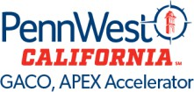

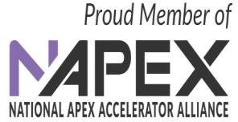

This APEX Accelerator is funded in part through a cooperative agreement with the Department of Defense.