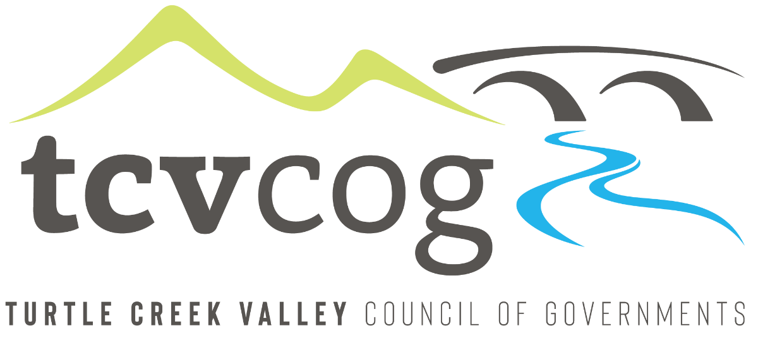
BIDS DUE: February 4th, 2025
Separate and sealed proposals will be received by the Turtle Creek Valley Council of Governments, 2700 Monroeville Boulevard, Monroeville, PA, 15146 until One (1:00) PM prevailing time on Tuesday, February 4, 2025. At that time, bids will be publicly open and read aloud for the following project(s)

CD48-3.11.8 – Demolition, Plum Borough

Bidding Documents may be purchased from KU Resources, 117 Sagamore Hill Road, Pittsburgh, PA 15239 by Emailed Electronic Copy only for $50.00 Payable to KU Resources;. A check in the amount of $50.00 must be sent to KU Resources, 117 Sagamore Hill Road, Pittsburgh, PA 15239 and a scanned copy of the check must be emailed to cprokopik@kuresources.com before Bidding Documents will be emailed out. Each proposal must be accompanied by a certified check or bid bond in the amount of not less than 10% of the total amount bid, made payable to Turtle Creek Valley Council of Governments.
Bids will be opened and read aloud on Tuesday, February 4, 2025 at 1:00 PM at the office of the Turtle Creek Valley Council of Governments, 2700 Monroeville Boulevard, Monroeville, PA 15146.
Compliance is required with the Davis-Bacon Act and other Federal Labor Standard Provisions; Title VI and other applicable provisions of the Civil Rights Act of 1964; the Department of Labor Equal Opportunity Clause (41 CFR 60 – 1.4); Section 109 of the Housing and Community Development Act of 1974; Executive Order 11625 (Utilization of Minority Business Enterprise); Executive Order 12138 (Utilization of Female Business Enterprise); in compliance with Section 504 of the Rehabilitation Act of 1973 and the Americans with Disabilities Act of 1990; the Allegheny County MBE/WBE Program enacted July, 1981, which sets forth goals of 13 percent Minority and 2 percent Female Business Enterprise; and the Allegheny County Ordinance #6867-12, setting forth goals of 5 percent Veteran-Owned Small Businesses. Further, notice is hereby given that this is a Section 3 Project under the Housing and Urban Development Act of 1968, (as amended) and must to the greatest extent feasible, utilize lower income residents for employment and training opportunities and Section 3 Business concerns and all contracts and subcontracts for this project shall contain the “Section 3 Clause” as set forth in 24 CFR, Part 135.38. Moreover, compliance is required by the prime contractor and all subcontractors with the Federal General Conditions included in the contract documents between the County of Allegheny through its Department of Economic Development and the operating agency. These Federal General Conditions are to be incorporated by reference into all construction contracts between operating agency and contractor, contractor and subcontractor(s), and subcontractor(s) and lower tiered subcontractor(s).
No bidder may withdraw his or her bid within sixty (60) days after the actual bid opening thereof. The TCVCOG reserves the right to reject any or all bids, alternates or parts of bids.
Amanda Settelmaier
Turtle Creek Valley Council of Governments
2700 Monroeville Boulevard
Monroeville, PA 15146
412-858-5115 - phone
412-858-5118 - fax

