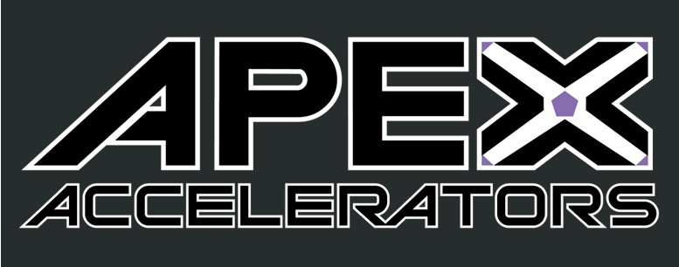
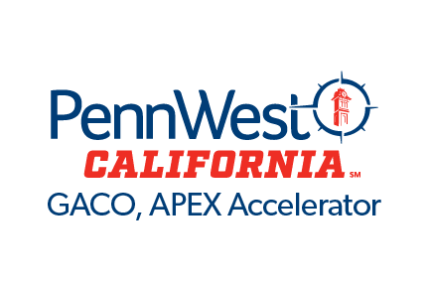
GACO’s

Quarterly Newsletter
February 2024

In This Issue
Department of Labor Increases Bid Threshold
FOCI
Quick Highlights
Agency Spotlight

The GACO, APEX Accelerator serves the Pennsylvania counties of Allegheny, Beaver, Butler, Greene and Washington
GovCon News
Department of Labor and Industry Announcement
On December 23, 2023, the Department of Labor & Industry published bid threshold increases to standalone procurements. Thresholds applicable to master agreements, ITQs or other contracting mechanisms may be higher. Increase information was published in the Pennsylvania Bulletin - Pennsylvania Bulletin (pacodeandbulletin.gov).

Foreign Ownership, Control or
Influence (FOCI)

To protect the security of the U.S. industrial base and government protected information, your business must evaluate the ownership interests of your organization. FOCI regulations can affect a company’s ability to maintain facility security clearance. If a company is found to be under FOCI, mitigation must be put in place to maintain or gain a facility security clearance. If a business chooses to not mitigate the risks their facility security clearance will be revoked. For more information review the Code of Federal Regulations CFR Title 32, Part 117.11.

eCRF:: 32 CFR 117.11 – Foreign Ownership, Control or Influence (FOCI)
Foreign Ownership, Control or Influence (dcsa.mil)

2
Contact Us
GACO, APEX Accelerator
250 University Ave
Box 20
California, PA 15419 724‐938‐5881
gacoapexaccelerator@pennwest.edu
www.calu.edu/gaco
Quick Highlights
- DoD Proposed Rule Change to CMMC 2.0 - UPDATE: DOD Proposed Rule Solidifies Plans for CMMC 2.0 Program: Security Requirements, Assessments, Affirmations, and Some Flow-Down Details | Wiley Rein LLP - JDSupra
- Pentagon’s Industrial Strategy calls for generational change to the Defense Industrial Base – Pentagon’s first industrial strategy calls for ‘generational’ change (defensenews.com)

- Proposed Changes to DoD Mentor Protégé Program – DoD Mentor-Protégé Program Solidified under Proposed Rule | Government Contracts Law

- DLA Link Newsletter – Issue 31, TheLink_Issue31_Jan2024.pdf (dla.mil)

- SAVE the DATE – Navy Gold Coast Small Business Procurement Event – August 19 - 21, 2024 – San Diego, Department of the Navy Gold Coast Small Business Procurement Event – 2024 Gold Coast Conference

Agency Spotlight – PA Department of General Services (DGS)

DGS is responsible for the execution of Pennsylvania’s
procurement policies. In the fall of 2023 Governor Shapiro
signed an executive order to increase the size standard
definition for small business and increase agency
procurement spend targets with small businesses.

Following Governor Shapiro's Executive Order, DGS Updates the Commonwealth's Small Business Definition By Raising Revenue Limit Threshold to Open More Doors of Opportunity for Small and Small Diverse Businesses (pa.gov)

