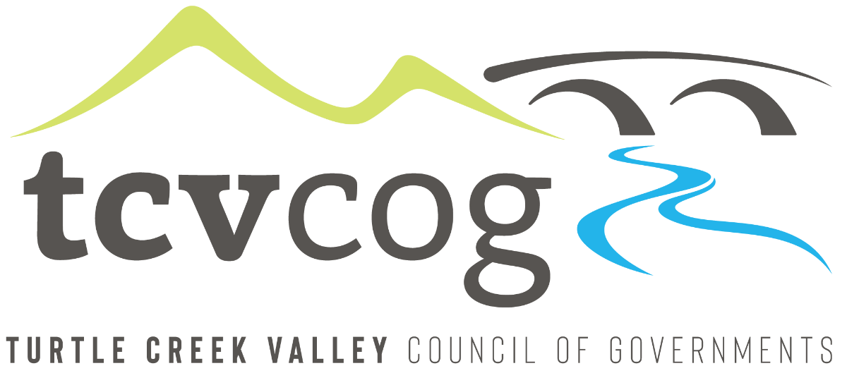

Separate and sealed proposals will be received by the Turtle Creek Valley Council of Governments, 2700 Monroeville Boulevard, Monroeville, PA, 15146 until One (1:00) PM prevailing time on Tuesday, January 7, 2025 for the following project(s)
2023-BRP-018- Act 152 Demolition, Turtle Creek
Copies of drawings, specifications and other contract documents may be examined or obtained for bidding purposes from Glenn Engineering and Associates, Ltd., 14920 Lincoln Highway, North Huntingdon, PA 15642. Fees for each document are One-hundred ($100.00) Dollars (non-refundable) payable to Glenn Engineering and Associates, Ltd. Requests for mailing will be honored with an additional fee of Eighteen ($18.00) Dollars for postage and handling. For additional information you may visit www.glennengr.com. NO DOCUMENTS WILL BE ISSUED WITHIN 48 HOURS OF THE SCHEDULED BID OPENING.
Bids will be opened publicly and read aloud on Tuesday, January 7, 2025 at 1:00 pm at the office of the Turtle Creek Valley Council of Governments, 2700 Monroeville Boulevard, Monroeville, PA 15146.
Compliance is required with the Pennsylvania Prevailing Wage Act of 1961, P.L. 987, No. 442; Title VI and other applicable provisions of the Civil Rights Act of 1964; the Department of Labor Equal Opportunity Clause (41 CFR 60 -1.4); Executive Order 11625 (Utilization of Minority Business Enterprise); Executive Order 12138 (Utilization of Female Business Enterprise); in compliance with Section 504 of Rehabilitation Act of 1973 and Americans with Disabilities Act of 1990; the Allegheny County MBE/WBE Program enacted July, 1981, which sets forth goals of 13 percent Minority and 2 percent Female Business Enterprise; and the Allegheny County Ordinance #6867- 12, setting forth goals of 5 percent Veteran Owned Small Businesses.
Each bid must be accompanied by a Bid Bond or Certified Check payable to the Turtle Creek Valley Council of Governments in an amount of not less than ten percent (10%) of the Base Bid. No bidder may withdraw his or her bid within sixty (60) days after the actual bid opening thereof. The TCVCOG reserves the right to reject any or all bids, alternates or parts of bids.
Amanda Settelmaier
Turtle Creek Valley Council of Governments
2700 Monroeville Boulevard
Monroeville, PA 15146
412-858-5115 - phone
412-858-5118 - fax

